**Title of the Project:**

Multi-Factor based Nutrient Management and Recipe Recommendation System

**Project Stream:** Data Intelligence Multimedia

**Statement about the Problem:**

Nutrient management in the context of this project aims to quantize the consumption of essential nutrients in an efficient format such that it leads to a healthy and balanced lifestyle. Several recent studies have shown the importance of quality-based consumption of nutrients which could otherwise lead to serious health issues that could even be fatal at times. The emergence of advanced scientific methods to determine the presence of various nutrients or lack thereof has led to widespread awareness amongst individuals to keep a track of their nutrient consumption. Increased consciousness towards one’s health has recently been in the limelight which creates the need for an intelligent system specially customized for the individual that can analyse your consumption’s quality and suggest options that could essentially fulfil your body’s need to lead a healthy lifestyle. The presence of this particular system can hugely impact individuals as this would save a considerable amount of time in finding a recipe that would not only suit the user’s preference but also encapsulate all the nourishing factors that an individual would require.

**Objective:**

The project's main goal is to create an intelligent recipe recommender that would aid in the development of a diet that allows all users to make healthy choices in their daily lives while still enjoying food and keeping healthy. The main objectives are :

* Develop an algorithm that maps the required nutrients tailored for every user to the information put in by them like age, gender, activity levels, diseases and allergies and personal health goals.
* Develop a classification model that can classify and output food groups that are rich in specific groups of nutritional values.
* Develop a ranking algorithm that maps the user inputs explaining their preferences and scrapes the web for recipes for the right diet.

**Scope of the Project:**

The recommender system once implemented as a mobile or web application, can help users who have nutritional deficiencies to maintain a healthy well balanced diet by suggesting various recipes to the users in video format with additional relevant information which will improve the user’s well-being and quality of life.

**Working Methodology:**

The working methodology can be explained clearly using the following flow-diagram. The setup will require the Application UI, preferable one made for mobiles to take in information from the user. The app will enable user to input information like their name, age, height, weight, diseases, medical history, nutritional preference, medications, allergies etc. The preference can include nutrients that the consumer wants to consume more of. This could be a nutrient the user is deficient in or one he needs for his personal health goals.

After receiving the necessary information, a user profile will be created and processed. The initial phase in the processing will be to take the nutritional preferences indicated by the user, as well as other information such as diseases, activity levels, and so on, and map these to information recorded from a database containing information about age-appropriate nutrition. This will result in a final set of nutritional values that the diet must meet for the specific user.

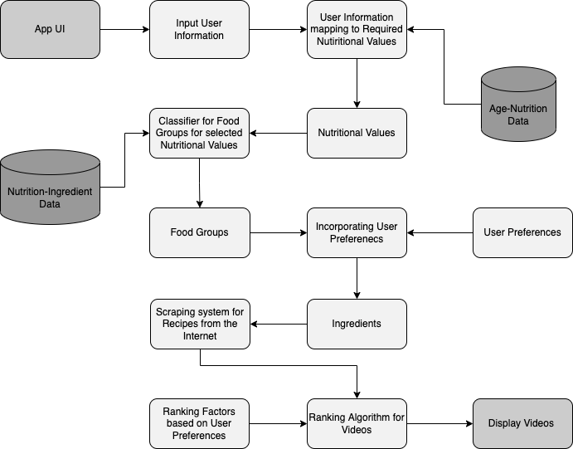

Using the Nutrition-Ingredient Data, the nutritional values would then be used to classify food groups (using a ML based classifier such as Random Forest) , resulting in the food groups that should be included in the diet. After taking into account the user's preferences, such as allergies and dislikes, a collection of ingredients will be developed that will be relevant for the recipe search.

A Deep Learning based Web Scraping system will use the ingredients generated to search for the videos that uses the ingredients in the recipe. These videos will be ranked based on the ranking preferences and shown on the Application UI.

The working methodology proposed is an improvement over the existing systems/research as it is expected to give higher accuracy at the stage of classification of food groups. It will also use a Deep Learning bases approach at the scraping system that will ensure faster and higher accuracy.

The proposed system is novel as it will combine and the ideas behind many advanced scientific researches that are done in part to achieve specific tasks to create an intelligent system that will have features like customization and tracking with higher accuracy that will aid in the development of a diet that allows all users to make healthy choices in their daily lives.

**Testing Technologies:**

A recommendation engine's performance can be tested, controlled, and measured in a variety of ways. The following are a few metrics which can be considered for testing and evaluation.

* **Coverage of users** with recommendations is an important factor, depending on the techniques implemented, the system might be able to generate recommendations to 1, 5, 42 or 100% of the users.
* **Coverage and diversity of items** the engine is capable of recommending. It is the measure of whether the system is recommending only 5% of all the available items. For a given user, are the recommendations diverse enough, e.g. items from different categories, price ranges, colors, etc.
* **System performances**. e.g. Can the system provide recommendations under 50ms at the 99.99th percentile? Depending on how the recommendations are used, one can set tight or loose constraints here.
* **Precision evaluation metrics**. Information retrieval systems are often evaluated using metrics like NDCG, Precision@K, Recall@K, MPR, MAE/RMSE (notably if you rely on explicit ratings). There can be good indications on whether or not the engine is meeting the desired expectations.

For each of the above metrics a threshold must be determined to accept or reject a recommendation engine.

**Limitations of the system proposed:**

Success of this project depends on the relevance of recipe videos displayed. Since it’s a research-based project, results and accuracy is experimental and the actual practicing accuracy will come into the picture much later in the workflow. Marketing of this project is important in order to get more accurate results, but this will be a full-time task with much resource demand.

**Contribution to the society:**

In a scientifically curious world that is moving towards fitness and raising awareness for quality consumption of micronutrients, our aim is to manufacture an intelligent system backed by state-of-the-art algorithms and design patterns that can solve the need for various individuals to keep track of their nutrient consumption. This project can take preferences from individuals (age, gender, height, weight, ingredient preference, etc..) and produce a list of ranked recipes that can fulfil all of the user’s needs to maintain a healthy lifestyle. This research might manufacture a system that can greatly contribute to the cause by saving a considerable amount of time in choosing an appropriate recipe to fulfil all needs and help individuals evade life-threatening health conditions and malnourishment.

**Guide Comments:**

Project statement addresses nutritional concerns very well. It aims at arriving a computer-based solution for suggesting healthy recipes based on the ingredients that the users could consume to increase their nutrient level. As a result, their immunity will increase and can lead a healthy living. Good topic of multi-disciplinary research